QUESTION 5

Title
Longest Repeating Sub-sequence Using Dynamic Programming

Aim
To find the length of the longest repeating sub-sequence in a given string using Dynamic Programming and analyze its efficiency.

Problem Statement
Given a string, determine the length of the longest sub-sequence that appears more than once without using the same character index in both occurrences.
The sub-sequences must be identical but should originate from different positions in the string.

Sample Input
AABEBCDD

Expected Output
Length = 3

Introduction
A sub-sequence is a sequence that can be derived from a string by deleting some characters without changing the order of the remaining characters.
In many applications such as bio-informatics, text analysis, pattern matching, and data compression, finding repeated patterns is important.
The Longest Repeating Sub-sequence (LRS) problem aims to identify the longest sub-sequence that occurs at least twice in a string.
Dynamic Programming provides an efficient solution by storing intermediate results and avoiding repeated calculations.

Objective
- Find the longest repeating sub-sequence.
- Avoid using the same character index twice.
- Apply Dynamic Programming for efficient computation.
- Analyze algorithm performance.
- Determine the maximum repeating length.

Theory
The Longest Repeating Sub-sequence problem is similar to the Longest Common Sub-sequence (LCS) problem.
The difference is that the string is compared with itself.
A character match is considered only when:
s[i] = s[j]
and
i ≠ j
This ensures that the same character position is not reused.

Dynamic Programming Approach
Let:
DP[i][j]
represent the length of the longest repeating sub-sequence considering the first i and j characters of the string.

Recurrence Relation
If:
s[i−1] = s[j−1]
and
i ≠ j
Then:
DP[i][j] = 1 + DP[i−1][j−1]
Otherwise:
DP[i][j] = max(DP[i−1][j], DP[i][j−1])

Algorithm

Step 1
Read the input string.

Step 2
Create a Dynamic Programming table of size (n+1) × (n+1).

Step 3
Compare every character with every other character.

Step 4
If characters match and indices are different, increase the subsequence length.

Step 5
Otherwise, store the maximum value from neighboring cells.

Step 6
Return the value stored in DP[n][n].

Pseudocode
LRS(s)

n ← length of string

Create DP[n+1][n+1]

FOR i ← 1 TO n

FOR j ← 1 TO n

IF s[i−1] = s[j−1] AND i ≠ j

DP[i][j] ← 1 + DP[i−1][j−1]

ELSE

DP[i][j] ← max(DP[i−1][j], DP[i][j−1])

RETURN DP[n][n]

Source Code
def longest_repeating_sub-sequence(s):

n = len(s)

dp = [[0 for j in range(n+1)] for i in range(n+1)]

for i in range(1, n+1):
for j in range(1, n+1):

if s[i-1] == s[j-1] and i != j:
dp[i][j] = 1 + dp[i-1][j-1]

else:
dp[i][j] = max(dp[i-1][j], dp[i][j-1])

return dp[n][n]

s = input("Enter String: ")

print("Length =", longest_repeating_subsequence(s))

Sample Input
AABEBCDD

Sample Output
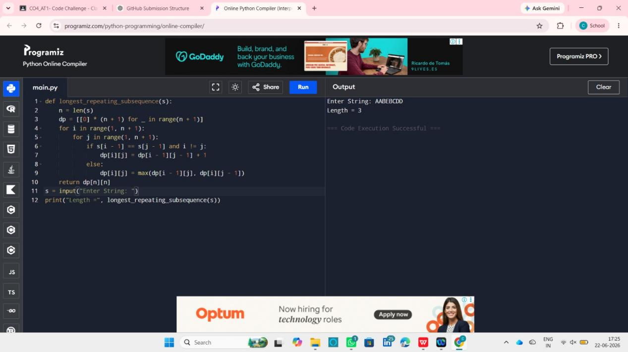

Working Example
Input String:
AABEBCDD
Longest Repeating Sub-sequence:
ABD
Length:
3

Analysis

Why Dynamic Programming?
- Avoids repeated calculations.
- Stores intermediate results.
- Provides efficient execution.
- Suitable for large input strings.

Advantages
- Optimal solution.
- Efficient memory usage.
- Faster than brute-force methods.
- Easy to implement.

Time Complexity
O(n²)
The DP table contains n × n entries.

Space Complexity
O(n²)
Additional space is required for the DP table.

Applications
- DNA Sequence Analysis
- Pattern Recognition
- Text Mining
- Data Compression
- Bioinformatics
- Natural Language Processing

Result
The Longest Repeating Sub-sequence was successfully identified using Dynamic Programming. For the input string "AABEBCDD", the longest repeating subsequence has a length of 3. The Dynamic Programming approach efficiently solves the problem with O(n²) time complexity and O(n²) space complexity.

